|  |  |
| --- | --- |
| **Team Id** | PNT2022TMID29528 |
| **Student Name** | **M.Niha amreen** |
| **Project Name** | **Customer care registry** |

**QUESTION:1**

1.Create a Bucket in IBM object storage

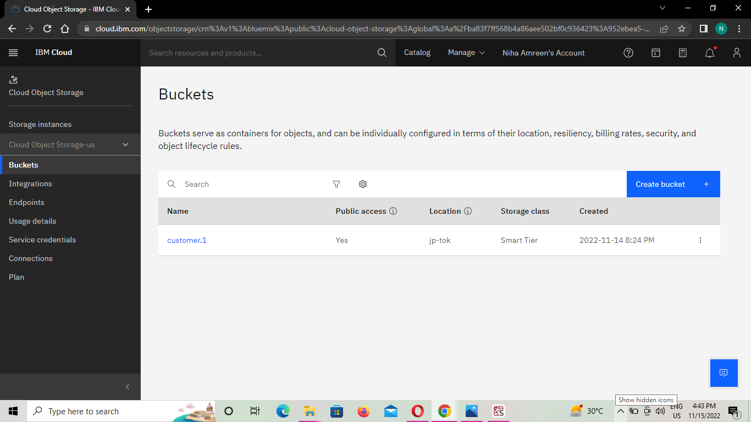

# Question-2:

2.Upload an 5 images to ibm object storage and make it public. write html code to displaying all the 5 images

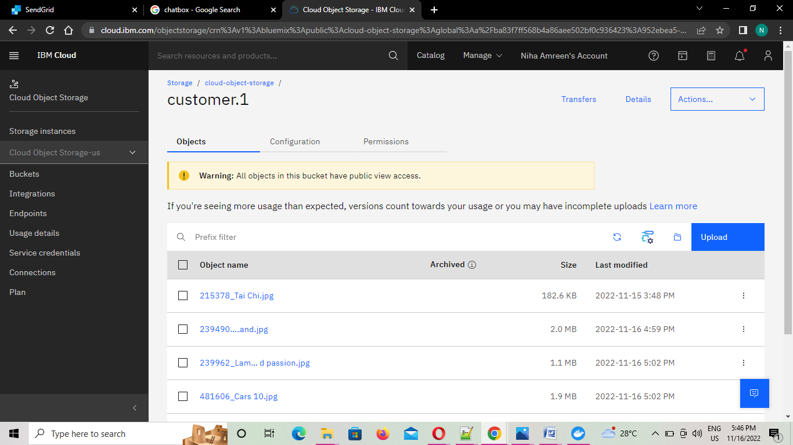

OUTPUT:

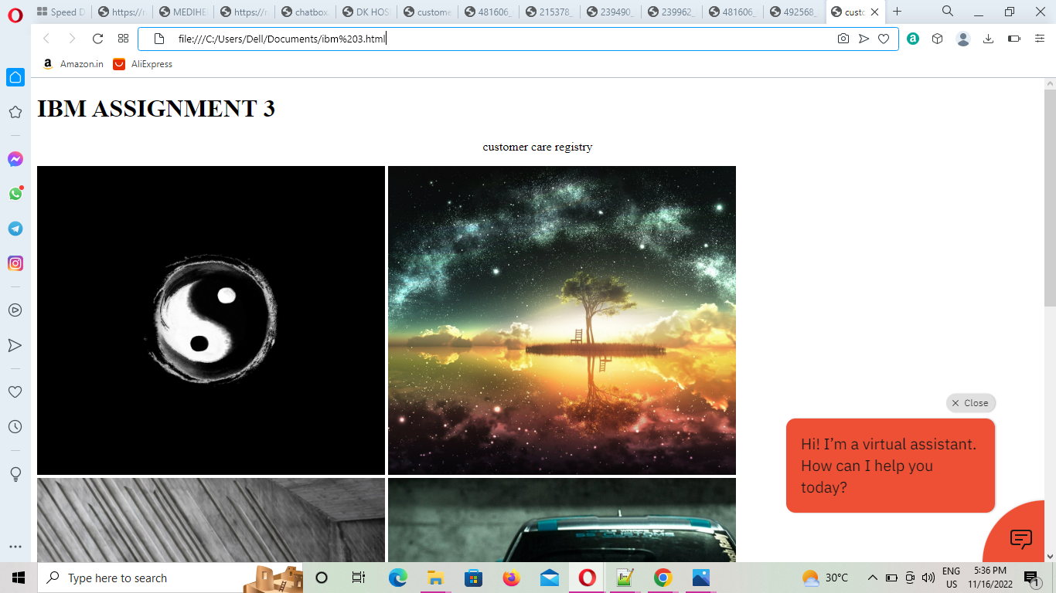

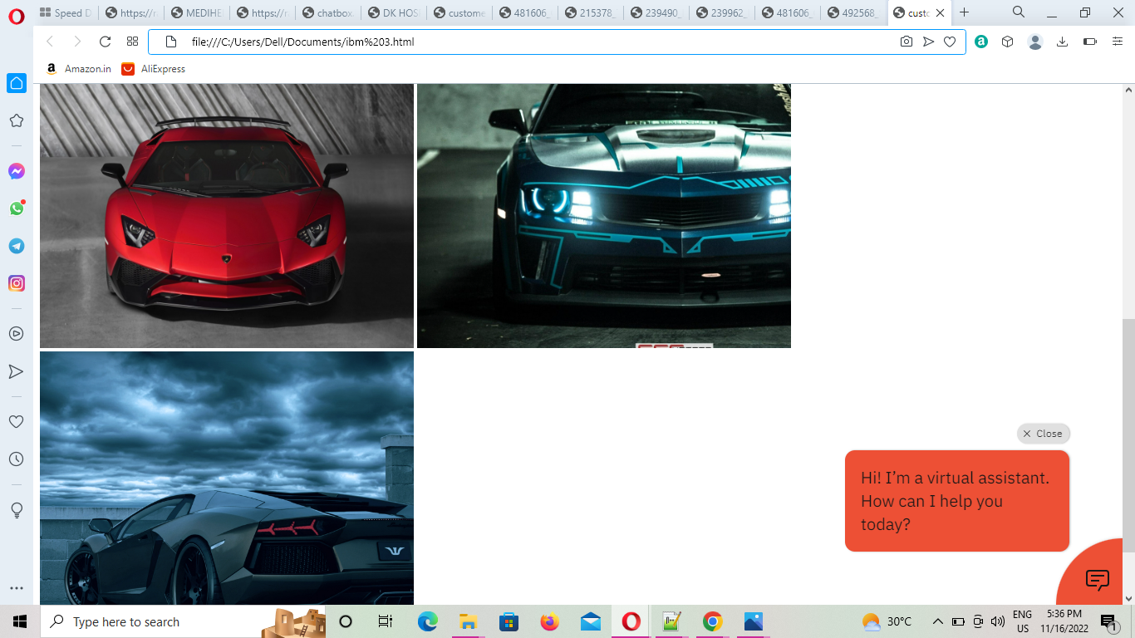

# index.html:

<!DOCTYPE html>

<html lang="en">

<head>

<meta charset="UTF-8">

<meta http-equiv="X-UA-Compatible" content="IE=edge">

<meta name="viewport" content="width=device-width, initial-scale=1.0">

<title>customer care registry</title>

</head>

<link rel="stylesheet" href="https://assignment3121.s3.jp-tok.cloud-objectstorage.appdomain.cloud/style.css">

<!-- <script src="https://cdnjs.cloudflare.com/ajax/libs/materialize/1.0.0/js/materialize.min.js"></script>

-->

<!-- <link rel="stylesheet"

href="https://cdnjs.cloudflare.com/ajax/libs/materialize/1.0.0/css/materialize.min.css"> -->

<body>

<style>

img{

height: 25rem !important;

}

.col{

height: 25rem !important;

}

</style>

<div class="wrapper">

<h1>IBM ASSIGNMENT 3</h1>

<p><center>customer care registry</center></p>

<div class="img-area">

<img class="activator " src="file:///D:/pictures/215378_Tai%20Chi.jpg">

<img class="activator " src="file:///D:/pictures/239490_Fairy%20Land.jpg">

<img class="activator " src="file:///D:/pictures/239962_Lamborghini-red%20passion.jpg">

<img class="activator " src="file:///D:/pictures/481606_Cars%2010.jpg">

<img class="activator " src="file:///D:/pictures/492568_SportsCar-6.jpg">

</div>

<script>

window.watsonAssistantChatOptions = {

integrationID: "cdfd03c8-a733-4b80-91cb-f2f1e34bda17", // The ID of this integration.

region: "au-syd", // The region your integration is hosted in.

serviceInstanceID: "ab9b9683-d04e-4af9-92ed-50ce38ac0c8c", // The ID of your service instance.

onLoad: function(instance) { instance.render(); }

};

setTimeout(function(){

const t=document.createElement('script');

t.src="https://web-chat.global.assistant.watson.appdomain.cloud/versions/" +

(window.watsonAssistantChatOptions.clientVersion || 'latest') + "/WatsonAssistantChatEntry.js";

document.head.appendChild(t);

});

</script>

</body>

</html>

# Question-3:

Upload a css page to the object storage and use the same page in your HTML code



**CUSTOMER CARE REGISTRY.HTML:**

<!DOCTYPE html>

<html lang="en">

<head>

<meta charset="UTF-8">

<meta http-equiv="X-UA-Compatible" content="IE=edge">

<meta name="viewport" content="width=device-width, initial-scale=1.0">

<title>customer care registry</title>

</head>

<link rel="stylesheet" href="https://assignment3121.s3.jp-tok.cloud-objectstorage.appdomain.cloud/style.css">

<!-- <script src="https://cdnjs.cloudflare.com/ajax/libs/materialize/1.0.0/js/materialize.min.js"></script>

-->

<!-- <link rel="stylesheet"

href="https://cdnjs.cloudflare.com/ajax/libs/materialize/1.0.0/css/materialize.min.css"> -->

<body>

<style>

img{

height: 25rem !important;

}

.col{

height: 25rem !important;

}

</style>

<div class="wrapper">

<h1>IBM ASSIGNMENT 3</h1>

<p><center>customer care registry</center></p>

<div class="img-area">

<img class="activator " src="https://customer.1.s3.jp-tok.cloud-object-storage.appdomain.cloud/215378_Tai%20Chi.jpg">

<img class="activator " src="https://customer.1.s3.jp-tok.cloud-object-storage.appdomain.cloud/239490_Fairy%20Land.jpg">

<img class="activator " src="https://customer.1.s3.jp-tok.cloud-object-storage.appdomain.cloud/239962_Lamborghini-red%20passion.jpg">

<img class="activator " src="https://customer.1.s3.jp-tok.cloud-object-storage.appdomain.cloud/481606_Cars%2010.jpg">

<img class="activator " src="https://customer.1.s3.jp-tok.cloud-object-storage.appdomain.cloud/492568_SportsCar-6.jpg">

</div>

<script>

window.watsonAssistantChatOptions = {

integrationID: "cdfd03c8-a733-4b80-91cb-f2f1e34bda17", // The ID of this integration.

region: "au-syd", // The region your integration is hosted in.

serviceInstanceID: "ab9b9683-d04e-4af9-92ed-50ce38ac0c8c", // The ID of your service instance.

onLoad: function(instance) { instance.render(); }

};

setTimeout(function(){

const t=document.createElement('script');

t.src="https://web-chat.global.assistant.watson.appdomain.cloud/versions/" +

(window.watsonAssistantChatOptions.clientVersion || 'latest') + "/WatsonAssistantChatEntry.js";

document.head.appendChild(t);

});

</script>

</body>

</html>

**Styles.css:**

body{

background-color: rgb(125, 222, 241);

}

img{ margin:20px;

border-color: rgb(175, 244, 254);

border-style: solid;

width:300px;

height:250px;

}

QUESTION:4

Chat Bot - Ginger (https://webchat.global.assistant.watson.appdomain.cloud/preview.html?backgroundImageURL=https %3A%2F% 2Fus-south.assistant.watson.cloud.ibm.com%2Fpublic%2Fimages%2Fupx-37ac1e13- ba05-43649892- 9f93f5d59696%3A%3A3e09fc9c-e564-4527-bbba16f77749aa43&integrationID=fb6fc2359aa8-428bb2d5-932576f8933a&region=ussouth&serviceInstanceID=37ac1e13-ba05-4364-98929f93f5d59696)

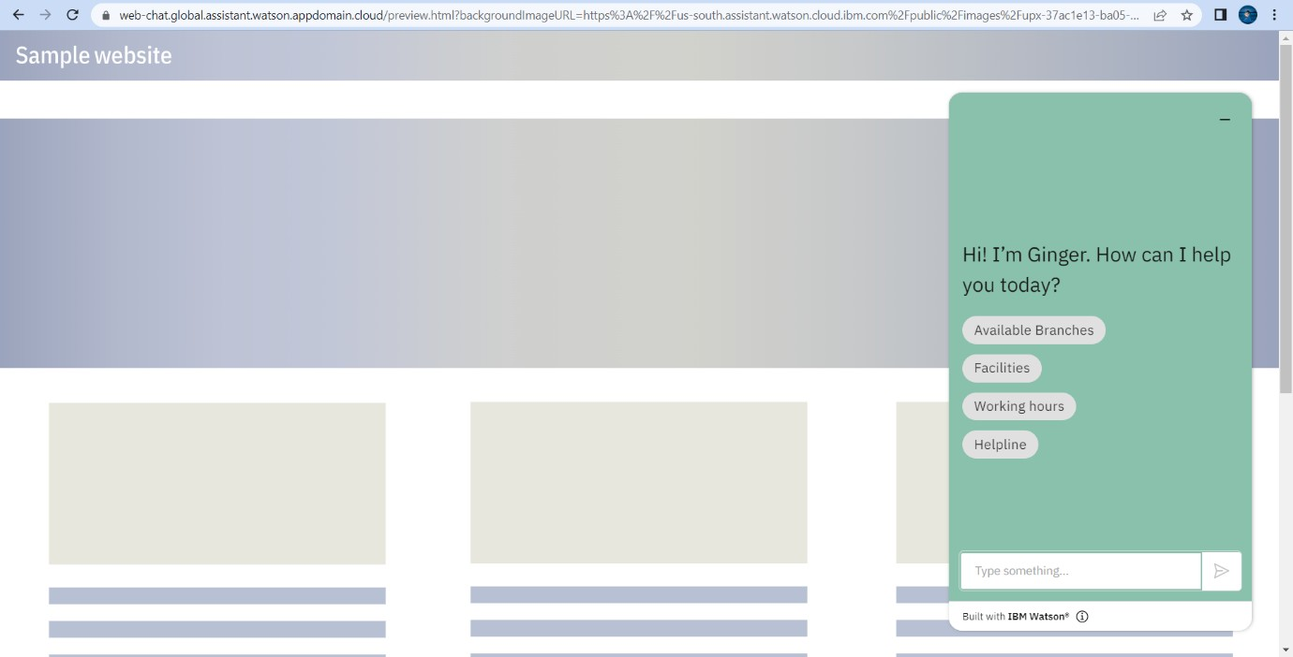

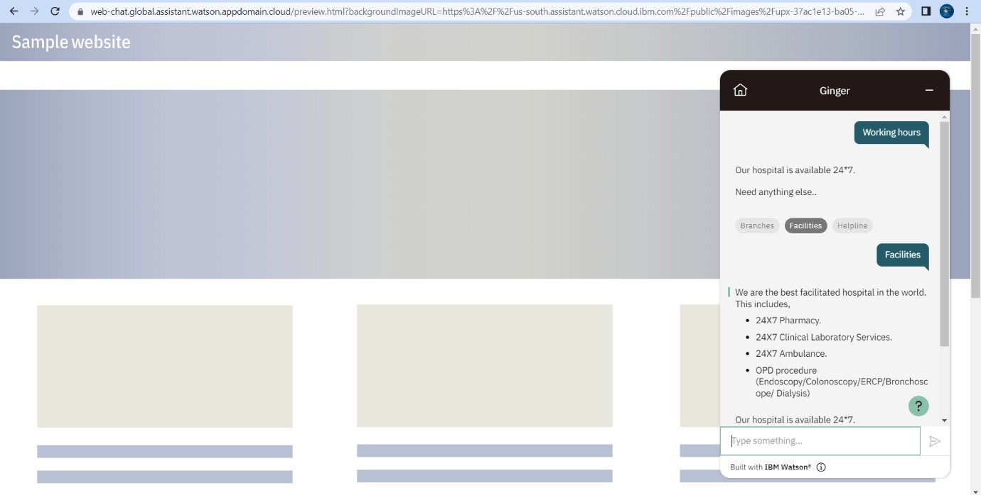

**QUESTION:5**

<!DOCTYPE html>

<html lang="en">

<head>

<meta charset="UTF-8">

<meta http-equiv="X-UA-Compatible" content="IE=edge">

<meta name="viewport" content="width=device-width, initial-scale=1.0">

<title>Sathya Ass-3</title>

</head>

<link rel="stylesheet" href="https://assignment3121.s3.jp-tok.cloud-object- storage.appdomain.cloud/style.css">

<!-- <script src="https://cdnjs.cloudflare.com/ajax/libs/materialize/1.0.0/js/materialize.min.js"></script>

-->

<!-- <link rel="stylesheet" href="https://cdnjs.cloudflare.com/ajax/libs/materialize/1.0.0/css/materialize.min.css"> -->

<body>

<style> img{

height: 25rem !important;

}

.col{

height: 25rem !important;

}

</style>

<div class="wrapper">

<h1>IBM ASSIGNMENT 3</h1>

<p><center>Sathya</center></p>

<div class="img-area">

<img class="activator " src="https://assignment3121.s3.jp-tok.cloud-object- storage.appdomain.cloud/air.jpg">

<img class="activator " src="https://assignment3121.s3.jp-tok.cloud-object- storage.appdomain.cloud/fire.jpg">

<img class="activator " src="https://assignment3121.s3.jp-tok.cloud-object- storage.appdomain.cloud/land.jpg">

<img class="activator " src="https://assignment3121.s3.jp-tok.cloud-object- storage.appdomain.cloud/sky.jpg">

<img class="activator " src="https://assignment3121.s3.jp-tok.cloud-object- storage.appdomain.cloud/water.jpg">

</div>

<script> window.watsonAssistantChatOptions = {

integrationID: "cdfd03c8-a733-4b80-91cb-f2f1e34bda17", // The ID of this integration. region: "au-syd", // The region your integration is hosted in.

serviceInstanceID: "ab9b9683-d04e-4af9-92ed-50ce38ac0c8c", // The ID of your service instance. onLoad: function(instance) { instance.render(); }

};

setTimeout(function(){

const t=document.createElement('script');

t.src="https://web-chat.global.assistant.watson.appdomain.cloud/versions/" + (window.watsonAssistantChatOptions.clientVersion || 'latest') + "/WatsonAssistantChatEntry.js";

document.head.appendChild(t);

});

</script>

</body>

</html>

# OUTPUT:

